**Lecture 2**

AWS-Launching-EC2-Instance

* AWS accounts are not region specific
* if an EC2 instance is in Canada Region, I can still make it in UAE region but the EC2 in UAE would be similar as it is in Canada region or any other region in the world.
* Login to AWS Console,
* 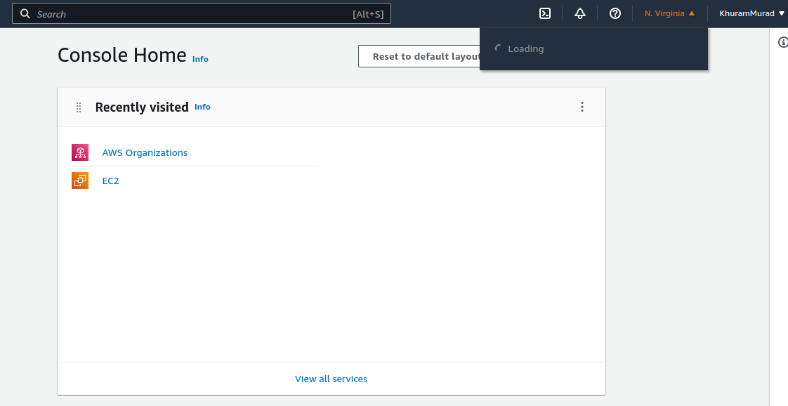EC2 → stands for “Elastic Compute Cloud”
* Create an Instance and access it from MobaXterm Home portable (free) version.
* Nore down the key with *.pem extension à same key can be used for multiple machines
* Open the instance in AWS
* Note its Public IP (it changes after ever restart) which is to be used in MobaXterm along with “the key” to get remote access of this instance.